COMPUTER SCIENCE DEPARTMENT EBONYI STATE UNIVERSITY ABAKALIKI - NIGERIA OFFICE OF THE HEAD OF DEPARTMENT TO: The Registrar FROM: HOD Computer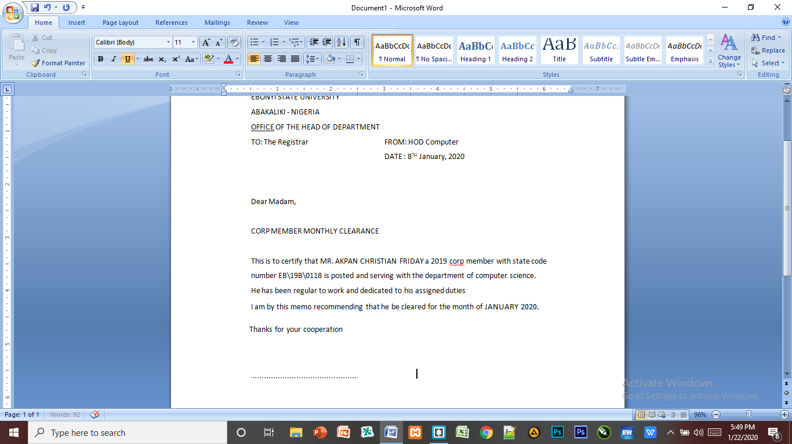 DATE : 8TH January, 2020 Dear Madam, CORP MEMBER MONTHLY CLEARANCE This is to certify that MR. AKPAN CHRISTIAN FRIDAY a 2019 corp member with state code number EB\19B\0118 is posted and serving with the department of computer science. He has been regular to work and dedicated to his assigned duties I am by this memo recommending that he be cleared for the month of JANUARY 2020.

Thanks for your cooperation DR. I. AJAH HOD Computer Science Department.